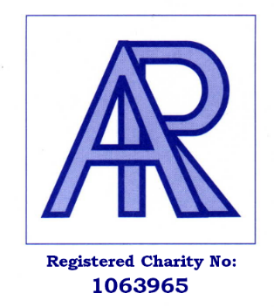
ASTHMA RELIEF CHARITY

The Shaftesbury Centre, Percy Street, SWINDON SN2 2AZ
Tel: 01793 524004
Fax: 01793 529005
Email: info@asthmarelief.org.uk
Website: www.asthmarelief.org.uk

Asthma Relief is a charity which was set up in 1997, by retired Swindon engineer, Dave Penman. Sadly, many years earlier Dave's 28 year old brother died following an Asthma attack. Dave had always hoped that when he retired from running his engineering business, he would be able to do something to help asthmatics and people with breathing problems.

However, in 1997, Dave suffered a massive heart attack and was advised by the doctors that he would not be able to work again. During his time in hospital, Dave noticed that several patients were sharing one nebuliser (a nebuliser is a device which is used to administer a solution of medication in the form of a fine mist for the patient to inhale, thus enabling them to breathe more easily). It was at this point that the idea of setting up a charity to support people with breathing difficulties by supplying nebulisers to them via hospitals, doctor's surgeries, community nurses, hospices and special needs schools, came to Dave. Asthma Relief was set up from Dave's hospital bed. Asthma Relief Charity donate over 1000 nebulisers a year, to people of all ages, throughout the UK. Due to the cost, nebulisers are not always freely available on the NHS. A nebuliser is easy to use and allows patients to be treated at home rather than in hospital.

Asthma Relief also provide battery operated portable nebulisers which can be particularly useful for young people at school or college and for people wishing to travel.
This is a quote from a severe asthma sufferer, who was hospitalised every 2-3 months. “Asthma Relief Charity has changed my life. I do not need to go to the hospital very often, I get out and have holidays! I am now married with a son, something I never thought possible”.
Another quote from a very grateful Grandmother and carer of her disabled granddaughter, “Thank you so much for the battery operated portable nebuliser donated to my granddaughter. This has already proved very useful when going out, it allows us to stay out longer. It really is life changing.”
Asthma Relief rely on donations and fundraising to enable the charity to purchase nebulisers which are vitally important in treating people with asthma, COPD, COVID 19 and other respiratory illnesses.
Donations can be made by Cheque: Payable to Asthma Relief Charity & sent to Asthma Relief Charity, The Shaftesbury Centre, Percy Street, Swindon SN2 2AZ , Online at CAF (Charities Aid Foundation) or Just Giving, which can be accessed via our website. For more information please contact us on 01793 524004 or visit our website www.asthmarelief.org.uk

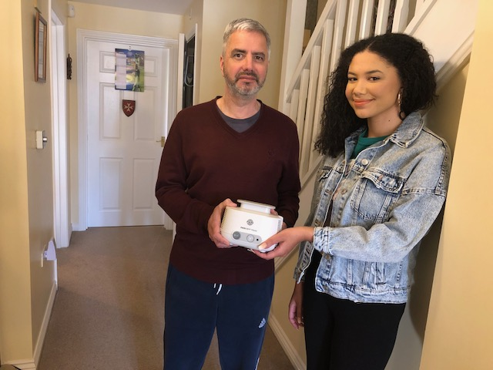
Asthma Relief wonderful volunteers Andy and Sophia pictured with a nebuliser compressor

